***Solving Equations with variables on sides***

***Notes***

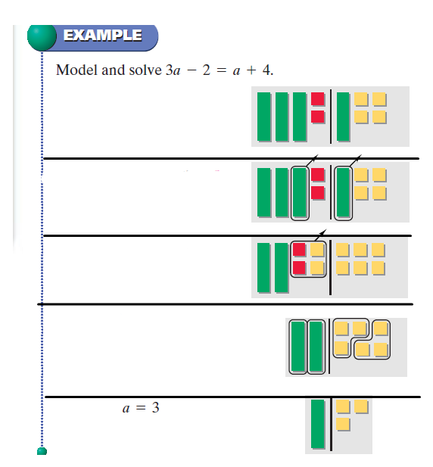 ***Problem of the day***

|  |
| --- |
| **Essential Question?** |
| 1._______________________________ |

**Steps for solving equations**

**1.___________________**

**2.___________________**

**3.____________________**

**4.____________________**

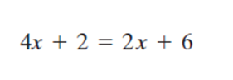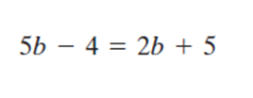

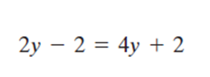 2a + 2 = a – 8

******In order to combine like terms the “like terms” need to be on the same side of the equation

1. -2x – 3 + 3x = -45 - 5x

Word Problems

1. A cell phone company offers 2 text message plans. One plan costs $5 plus $0.20 per message and the other plan costs $10 plus $0.10 per message. When do the two plans cost the same?
2. Referring to the square shown, find the value of *a*.

*a*+14

4*a*+2

1. Using an equation, find the value of the variable that will make the perimeter of each shape the same.

*b*+6

*b*+7

*b*+5

*b*+4

*b*+2

1. -2x – 3 + 3x = -45 - 5x 3. -11c = 4c + 7 - 14c + 8
2. 4b – 4 – 19b = -11b + 12 4. -2x – 3 + 3x = -45 - 5x
3. Sprint charges $49.99 for a 3G/4G mobile hotspot and $34.99 per month for service.  
   Verizon has a 4G LTE mobile hot spot on sale for $19.99 and $49.99 per month.

How long before you would spend the same amount on both plans?

1. Using an equation, find the value of the variable that will make the perimeter of each shape the same.

2*c*+3

2*c*+2

2*c* +1

1.2*c*

1.2*c*

1.2*c*

1.2*c*

1.2*c*

1.2*c*

1.2*c*

1.2*c*

1.2*c*

1.2*c*

1. Find the value of *d* so that the perimeter of the square is equal to the area.

½*d*

½*d*

1. A number plus ten is equal to two times the same number plus 5.  
   Define a variable, write an equation and solve it to find the number.
2. Eighteen less than an integer is ten more than eight times that same integer.  
   Define a variable, write an equation and solve it to find the number.

